**1:1 Hydrofluoric Acid**

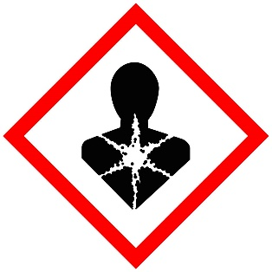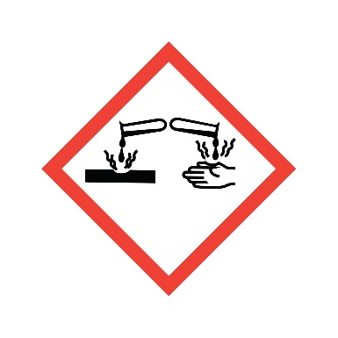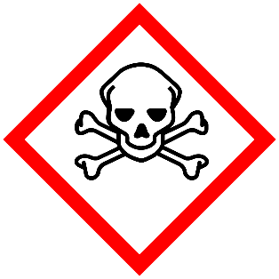

**Danger**

Fatal in contact with skin. Toxic if inhaled or swallowed. Causes severe skin burns and eye damage. May damage organs.

**1:1 HF**